SEC Adopts Rule 204(b)-1 (the "Rule") under the Investment Advisers Act of 1940, as amended (the "Advisers Act"), which implements Sections 404 and 406 of the Dodd-Frank Act. The Rule requires certain SEC registered investment advisers to make periodic informational filings on Form PF detailing certain information with respect to private funds that they manage.

Who Has to File Form PF?
First and foremost, only SEC-registered investment advisers are required to file Form PF. If you are a state registered investment adviser or are otherwise not required to register with the SEC as an investment adviser (for example, if you qualify for the exemption from SEC registration under Section 203(m) and Rule 203(m)-1 of the Advisers Act), you are not required to file Form PF under the Rule. In addition, even if you are an SEC-registered investment adviser, if you do not have at least $150 million in regulatory "assets under management" ("AUM") in one or more private funds (or managed accounts using a substantially similar investment strategy if such managed accounts do not have a gross asset value in excess of that of the private fund(s) that are similarly managed) as of the last day of your most recent fiscal year, you are not required to file Form PF under the Rule.

When Do I Have to File Form PF?
Private fund advisers come in three flavors - (1) hedge fund advisers, (2) liquidity fund advisers and (3) private equity fund advisers - and within each type of private fund adviser, there is a "large adviser" category. Large advisers are generally required to provide more extensive information more frequently than smaller advisers that do not meet the large adviser criteria. For a hedge fund adviser, the regulatory AUM that creates a large adviser reporting obligation is $1.5 billion attributable to hedge funds. For a liquidity fund adviser, the regulatory AUM that creates a large adviser reporting obligation is $1 billion attributable to liquidity funds and registered money market funds. Finally, for a private equity fund adviser, the regulatory AUM that creates a large adviser reporting obligation is $2 billion attributable to private equity funds.

The definitions of "hedge funds," "liquidity funds" and "private equity funds" for the purposes of Form PF are beyond the scope of this Alert, but each term is defined in the SEC's Adopting Release (Release No. IA-3308 available at www.sec.gov/rules/final/2011/ia-3308.pdf).

Large hedge fund and liquidity fund advisers are required to file Form PF on a quarterly basis - hedge fund advisers must file Form PF within 60 days of the end of each calendar quarter and liquidity fund advisers must file Form PF within 15 days of the end of each calendar quarter. Large private equity fund advisers, as well as all smaller advisers, are required to file Form PF annually within 120 days of the end of their fiscal year.

The initial compliance date for most SEC-registered investment advisers is December 15, 2012. However, SEC-registered investment advisers with at least $5 billion in regulatory AUM attributable to any one type of private fund will be required to comply with the Rule following the end of their first fiscal year or fiscal quarter on or after June 15, 2012.

The chart below summarizes the expected filing dates (assuming calendar fiscal quarters and years):
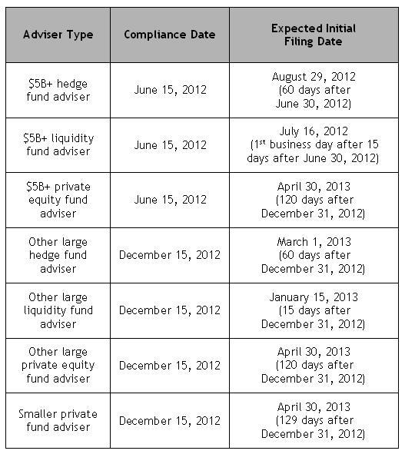
The filing fee for Form PF is $150 for an initial, quarterly or annual filing.

Navigating Form PF
Form PF has four sections.
- Section 1 is for any adviser that has to complete the form and requires certain identifying information about the adviser and its private fund(s) at a somewhat higher level than the remainder of the form.
  - Section 1a asks for identifying information of your firm, a breakdown of the regulatory AUM and net assets and the types of private funds your firm manages.
  - Section 1b goes into more detail about each of the private funds your firm manages such as gross and net asset value, assets in parallel managed accounts, information on leverage levels and counterparties, valuations of assets using FAS 157 type asset classifications, information on investor types and investment performance.
  - Section 1c asks about investment strategy characterization, trading levels, identity of significant counterparties and counterparty credit risk and information on trading and clearing. The vast majority of investment advisers that are required to file Form PF under the Rule will complete only Section 1.
- Section 2 must be completed by investment advisers that manage hedge funds with an aggregate regulatory AUM of at least $1.5 billion. Large hedge fund advisers must report, on an aggregated basis, information regarding exposures by asset class, geographical concentration and turnover by asset class. In addition, investment advisers to hedge funds having a net asset value of at least $500 million must report certain information relating to that fund's exposures, leverage, risk profile and liquidity. Large hedge fund advisers do not need to report position-level information.
- Section 3 must be completed by investment advisers that manage liquidity funds with an aggregate regulatory AUM of at least $1 billion. Large liquidity fund advisers must report information on the types of assets in each of their liquidity fund's portfolios, information regarding risk and the extent to which the fund has a policy of complying with the Investment Company Act's rule relating to registered money market funds (Rule 2a-7).
- Section 4 must be completed by investment advisers that manage private equity funds with an aggregate regulatory AUM of at least $2 billion. Large private equity advisers must report on the extent of leverage incurred by their funds' portfolio companies, the use of bridge financing and their investments in financial institutions.
Information reported on Form PF will remain confidential.

Jeff Blumberg is a partner at Fox, Hefter, Swibel, Levin & Carroll, LLP specializing in investment management law and is a member of the firm's Corporate and Securities practice group, where he provides counsel regarding regulatory, organizational, structural and business matters for a variety of registered and unregistered money managers, including hedge fund managers, investment advisers, broker-dealers, commodity trading advisors and commodity pool operators. Jeff received his J.D. from Chicago-Kent College of Law.

